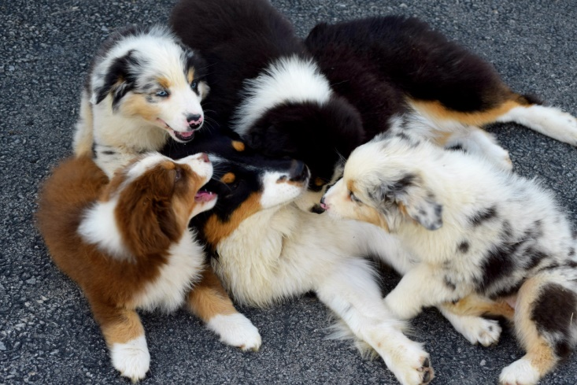

Danell Australian Shepherds
PUPPY QUESTIONNAIRE
In order to begin this process we ask that you ﬁrst complete the questionnaire below. We will than contact you in a timely manner and discuss further in what you’re hopes are from us and vice versa. If after we talk, we mutually feel that one of our puppies is right for you, a non-refundable holding fee of $200. 00 will be required to be placed on our waiting list. No puppy reservation or puppy will be held without a deposit. Priority is given to show, performance, and active homes but companion puppies are almost always available from each litter. Puppies will not be knowingly placed with specific homes till the puppies are properly evaluated for structure and temperament at 7-8weeks of age. This helps us better determine which puppy is better suited for each wonderful home.
Tremendous care, expertise, time and effort go into the raising one of our puppies so we politely ask that no requests for "discounted" pricing for any of our puppies and older dogs. We appreciate this in advance.
Our puppies are raised in our homes and are given daily socialization, experiencing a variety of situations appropriate to their ages from birth until they are ready to leave. We invest a tremendous amount of time into our puppies to ensure that they will be well rounded individuals. They are raised on high quality kibble and we expect the same from our new puppy homes. Before puppies leave, they will be microchipped, registration setup, and leave with a puppy package kit.
All of our puppies are registered with the American Kennel Club (AKC) and the Australian Shepherd Club of America (ASCA). All puppies are from parents who have been and not limited to, certiﬁed for Hip/Elbow clearances through the Orthopedic Foundation for Animals (OFA) to check for dysplasia, and Eye clearances from a certified canine ophthalmologist. In addition, all puppies’ eyes are checked for hereditary defects by a Certiﬁed Ophthalmologist before leaving us at over 9 weeks of age.
Companion Puppies: These are puppies perfectly suited as friends and companions and can be shown in performance events (unless otherwise noted), such as obedience, agility, herding, tracking and rally. They have simply been determined by us not to be used for breeding or the conformation ring. These puppies will be sold on a Spay/Neuter contract. Prices for companion puppies are $1800.
Show/Breeding Quality Puppies: These puppies have been determined at 8 weeks of age to be prospects for the conformation ring and/or breeding program. They will be sold with full privilege AKC/ASCA Registration papers. These puppies are usually co-owned with Danell and are required to ﬁnish their championships in AKC and/or ASCA and be OFA and CERF before being considered for breeding. Breeding/Show quality puppies will be sold to SERIOUS show homes only. Prices for show/breeding quality puppies are dependent on the speciﬁc breeding as well as availability. Pricing and contracts will be handled by private agreement.
If you still feel a Danell puppy may be right for you, please complete the following questionnaire and we will contact you. Thank you!
QUESTIONNARIE
Name:
Kennel Name (if applicable):
Address:
City: State: Zip:
E-mail Address:
Home phone:
Cell phone:
Are you over 18? If no, please include parent’s name:
Children at home: Ages:
Do you own, rent or other?
Do you have a fenced yard?
Where will the dog primarily live (inside, outside, etc?):
Will you use a crate for the dog?:
Will anyone be home during the day with the dog?:
If no, how many hours will the dog be alone during the day?: If no, where will the dog be kept while it is alone?:
Who will be the dog’s primary care giver?:
Have you previously trained a dog? If yes, in what areas?
Have you previously titled a dog? If yes, what titles?
Have you previously bred dogs? If yes, please describe:
Dogs previously owned & why no longer owned:
Dogs currently owned (please include breeds, gender, and age):
If you have not owned an Aussies before, brieﬂy tell us what attracted you to this breed:
Brieﬂy tell us what your goals are for this particular puppy and if you’re interested in a companion, performance, show, and or breeding dog:

Do you have a preference in gender or color? Also are you flexible if the color and/or gender is not available?**Please note that we take into account a color preference but it cannot be guaranteed as we place where the puppy will best match and compliment with their homes. We do NOT take eye color requests**

References (Name and phone number or e-mail), Vet may be one of the references:

(If you are inquiring about a show/breeding quality puppy we require references from breeders whom you have purchased dogs from previously)

Please fill this out and email the filled form to danellaussies@gmail.com

